IPL Player Performance Analysis Project Documentation

# Project Overview

This project showcases a comprehensive analysis of IPL player performance statistics, combining Python-based data cleaning with interactive visualizations built in Power BI. The primary goal was to extract actionable insights on batting and bowling performance and highlight top players across metrics.

## Data Cleaning & Preparation (Python)

Performed using the pandas, matplotlib, and seaborn libraries, the notebook focused on preparing the dataset for accurate reporting in Power BI.

**Steps followed:**

Null Handling:

Removed rows and columns with missing values in key metrics like Runs_Scored, Balls_Faced, and Wickets_Taken.

Duplicate Removal:

Used df.duplicated() and dropped duplicate entries to ensure clean year-wise data.

Data Type Correction:

Converted all numerical columns to proper formats (int or float).

Ensured categorical data like Player_Name and Year were correctly formatted.

Index Resetting:

Applied df.reset_index(drop=True) after transformations for clean DataFrame structure.

Exploratory Data Analysis (EDA):

Used violin plots, histograms, and trend lines to explore distributions.

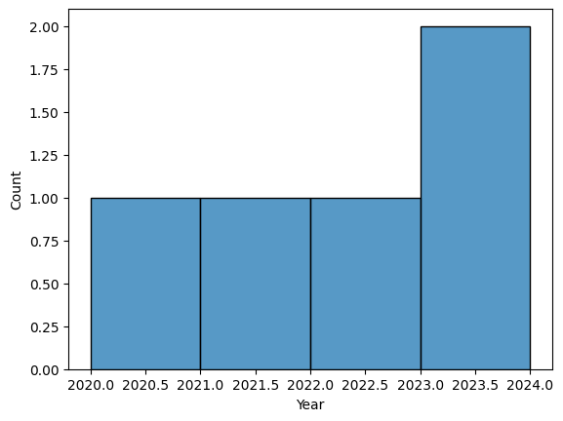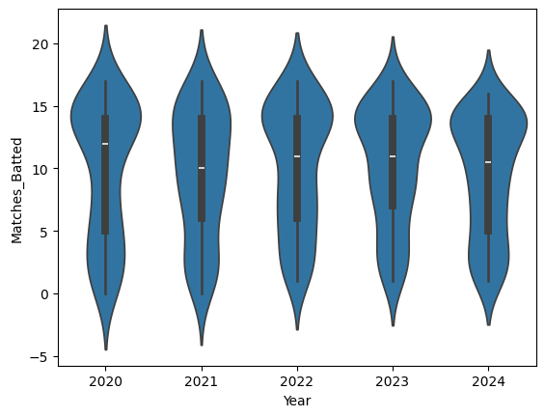

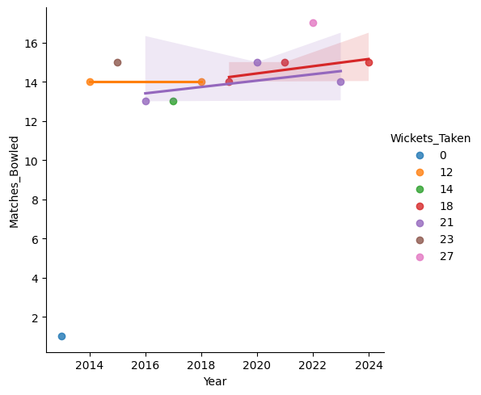

Analyzed year-wise patterns and outliers before exporting cleaned data to Excel using openpyxl.

## Data Visualization (Power BI)

The Power BI dashboard is split into three pages: Batting Analysis, Bowling Analysis, and Combined Summary.

### 1. Batting Analysis Page

**Visuals:**

Gauge Chart: Displays calculated average batting strike rate.

KPIs: Total Runs, Batting Average, Boundaries, Avg Strike Rate.

Column Chart: Top 5 Players by Average Strike Rate.

Line Chart: Avg Strike Rate over years.

Donut Chart: Comparison between Avg Strike Rate & Highest Score.

**Key DAX Measures:**

Avg Batting Strike Rate =

DIVIDE(SUM('PlayerStats'[Runs_Scored]) * 100, SUM('PlayerStats'[Balls_Faced]))

Top5_AvgStrikeRate =

AVERAGEX(

TOPN(5, SUMMARIZE('PlayerStats', 'PlayerStats'[Player_Name], "AvgSR",

AVERAGE('PlayerStats'[Batting_Strike_Rate])), [AvgSR], DESC),

[AvgSR]

)

**Insights:**

Highest strike rate: 333.33

Top batters: Jake Fraser-McGurk, Will Jacks, Phil Salt

### 2. Bowling Analysis Page

**Visuals:**

KPIs: Avg Wickets per Player, Bowling Average, Economy Rate, Bowling Strike Rate.

Bar Chart: Top 5 Bowlers by Wickets.

Bubble Chart: Bowling Strike Rate vs Economy by Player.

Line Chart: Year-wise trend of Economy Rate.

**Key DAX Measures:**

Avg Economy Rate = AVERAGE('PlayerStats'[Economy_Rate])

Avg Bowling Strike Rate = AVERAGE('PlayerStats'[Bowling_Strike_Rate])

Avg Wickets per Player =

AVERAGEX(

VALUES('PlayerStats'[Player_Name]),

SUM('PlayerStats'[Wickets_Taken])

)

**Insights:**

Best bowler: Yuzvendra Chahal with 205 wickets.

Economy rate trending higher over recent seasons.

### 3. Combined Summary Page

**Layout:**

Best Batter: Virat Kohli

Total Runs: 8004

Avg Strike Rate: 128.98

Avg Boundaries: 41.47

Best Bowler: Yuzvendra Chahal

Total Wickets: 205

Bowling Strike Rate: 16.45

Economy Rate: 7.89

**Methodology:**

Used DAX to filter by player name and compute total and average values.

Custom layout with transparent player images and background visuals.

